**SHRI SHANKARACHARYA TECHNICAL CAMPUS**

BACHELOR OF ENGINEERING IN MECHANICAL ENGINEERING

A PROJECT REPORT ON

DESIGN OF ROAD WASTE HEAT RECOVERY SYSTEM

SUBMITTED TO

CHHATTISGARH SWAMI VIVEKANAND TECHNICAL UNIVERSITY

SESSION:-2021-2022

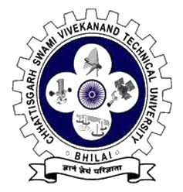

Submitted By:-

Aditya Verma (Roll No.301403719300)

Approved By:- Guided By:-

Dr. Jeetendra Kumar Tiwari Prof. Siddharth Tiwari